UNIT –IV
NETWORK MODEL & HIERARICHAL MODEL
I. Network Model:- In the relational model, the data and the relationships among data are represented by a collection of tables. The network model differs from the relational model in that data are represented by collections of records, and relationships among data are represented by links.
1. Basic Concepts :- A network database consists of a collection of records connected to one another through links. A record is in many respects similar to an entity in the E-R model. Each record is a collection of fields (attributes), each of which contains only one data value. A link is an association between precisely two records. Thus, a link can be viewed as a restricted (binary) form of relationship in the sense of the E-R model.
As an illustration, consider a database representing a customer-account relationship in a banking system. There are two record types, customer and account. As we saw earlier, we can define the customer record type, using Pascal-like notation:
type customer = record
customer name: string; customer street: string; customer city: string;
end
The account record type can be defined as
type account = record
account number: string; balance: integer;
end
/*The sample database in Figure 1 shows that Hayes has account A-102, Johnson has accounts A-101 and A-201, and Turner has account A-305.
*/
2. Data-Structure Diagrams :- A data-structure diagram is a schema representing the design of a network database. A data-structure diagram serves the same purpose as an E-R diagram; namely, it specifies the overall logical structure of the database. Such a diagram consists of two basic components:
1. Boxes, which correspond to record types
2. Lines, which correspond to links
- For every E-R diagram, there is a corresponding data-structure diagram.
- Since a link cannot contain any data value, represent an E-R relationship with attributes with a new record type and links
3. General Relationships :- Consisting 3 entity sets
To represent an E-R relationship of degree 3 or higher, connect the participating record types through a new record type that is linked directly to each of the original record types.
1. Replace entity sets account, customer, and branch with record types account, customer, and branch, respectively.
2. Create a new record type Rlink (referred to as a dummy record type).
3. Create the following many-to-one links:
_ CustRlink from Rlink record type to customer record type
_ AcctRlnk from Rlink record type to account record type
_ BrncRlnk from Rlink record type to branch record type
Many to Many:
One to Many from customer to account:
One to One:
II. The DBTG CODASYL Model :- The first database-standard specification, called the CODASYL DBTG 1971 report,was written in the late 1960s by the Database Task Group.
- Link Restriction:-
  - All links are treated as many-to-one relationships.
  - To model many-to-many relationships, a record type(dummy) is defined to represent the relationship and two links are used.

2. DBTG Sets:-
- The structure consisting of two record types that are linked together is referred as a DBTG set in the DBTG model. It is used to describe inter-record structures.

Fig :- DBTG set
  - In each DBTG set, one record type is designated as the owner, and the other is designated as the member, of the set. (The name of the set is usually chosen to be the same as the name of the link connecting the two record types.)
  - Eg. a Depositor (1:M) link:
The DBTG Set (Depositor) is {(a1,(b1,b2)), (a2,(b3,b4,b5)), (a3,(b6))}
  - Consider:
An account, b2 of a1, cannot appear as an account of any other customer record (the same DBTG set). But b2 can appear as a member of a branch record
(another DBTG set) i.e. Each DBTG set can have any number of set occurrences (actual instances of linked records).
Figure :- 3 set occurrences

  - Since many-to-many links are disallowed, each set occurrence has precisely one owner, and has zero or more member records.
For eg:-
- depositor, which has customer as the owner of the DBTG set, and account as the member of the DBTG set
- account branch, which has branch as the owner of the DBTG set, and account as the member of the DBTG set
- The set depositor can be defined as follows:
    - set name is depositor
    - owner is customer
    - member is account
- The set account branch can be defined similarly:
    - set name is account branch
    - owner is branch
    - member is account
Figure Data-structure diagram.
- Repeating Groups :- The DBTG model provides Repeating Group mechanism for:
- A field to have a set of values rather than a single value.
- It also provide alternative representation of weak entities from the E-R model
- Example: Two sets.
    - Customer(strong entity) (customer-name)
    - customer-address(weak entity) (customer-street, customer-city)
The following diagrams represent these sets without the repeating-group construct.
With the repeating-group construct, the data-structure diagram consists of the single record type customer.
III. DBTG Data-Retrieval Facility :-
The data-manipulation language of the DBTG proposal consists of commands that are embedded in a host language./* In this section, we present several of these commands, and use Pascal as the host language.*/
- Program Work Area:- Each application program executing in the system consists of a sequence of statements; some are Pascal statements, whereas others are DBTG command statements. Each such program is called a run unit.
These statements access and manipulate database items, as well as locally declared variables.
For each such application program, the system maintains a program work area (referred to in the DBTG model as a user work area), which is a buffer storage area that contains the following variables:
- Record templates: A record (in the Pascal sense) for each record type accessed by the application program.
- Currency pointers: A set of pointers to various database records most recently accessed by the application program; currency pointers are of the following types:
◦ Current of record type: One currency pointer for each record type T referenced by the application program; each pointer contains the address (location on disk) of the most recently accessed record of type T.
◦ Current of set type: One currency pointer for each set type S referenced by the application program; each pointer contains the address of the most recently accessed record of that set type; note that this pointer may point to a record of either the owner or member type, depending on whether an owner or a member was most recently accessed.
◦ Current of run unit: One single currency pointer, containing the address of the record (regardless of type) most recently accessed by the application program
• Status flags: A set of variables used by the system to communicate to the application program, the outcome of the last operation applied to the database. The most frequently used one is DB-status, set to 0 if the most recent operation succeeded and otherwise set to an error code. The additional status variables (DB-set-name, DB-record-name, and DB-data- name) are set when the final operation fails, to help identify the source of the difficulty.
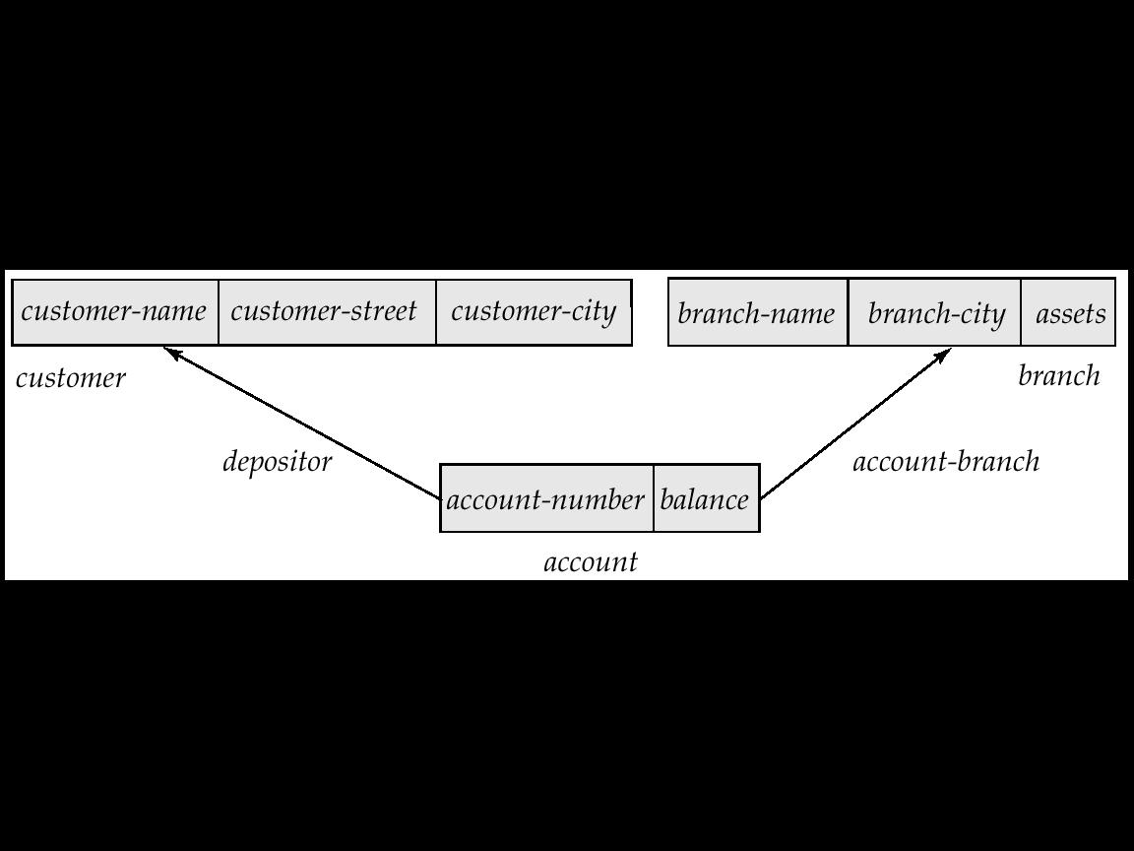 c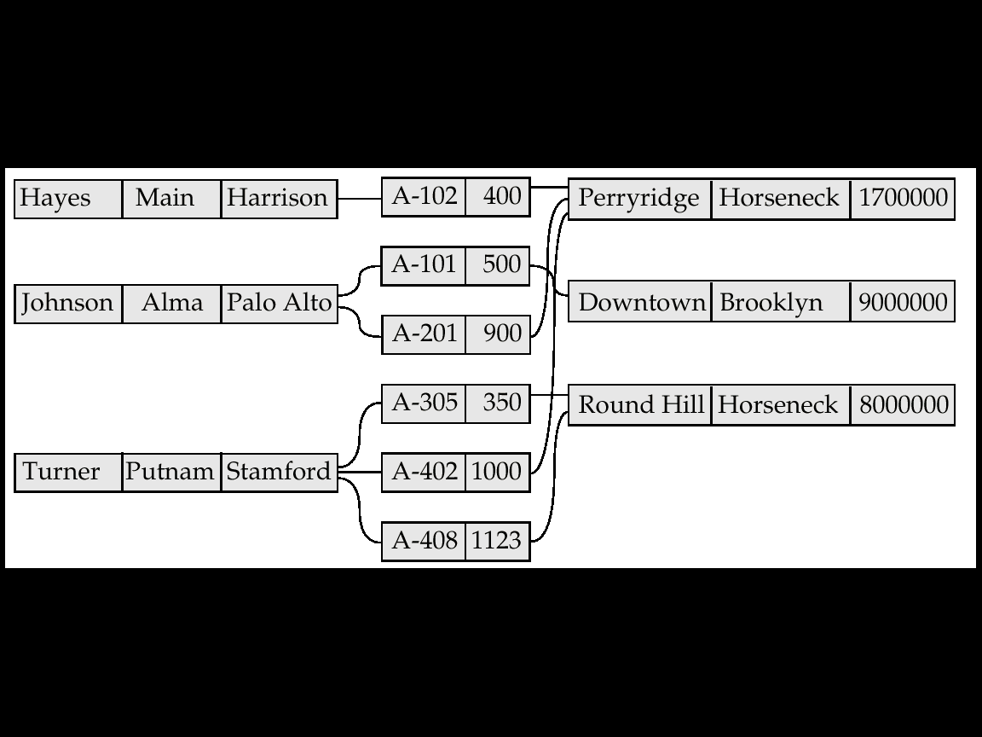
/* We emphasize that a particular program work area is associated with precisely one application program. For our customer-account-branch database example, a particular program work area contains the following:
• Templates: three record types:
◦ customer record
◦ account record
◦ branch record
• Currency pointers: six pointers:
◦ Three currency pointers for record types: one to the most recently accessed customer record, one to the most recently accessed account record, and one to the most recently accessed branch record
◦ Two currency pointers for set types: one to the most recently accessed record in an occurrence of the set depositor, and one to the most recently accessed record in an occurrence of the set account branch
◦ One current of run-unit pointer
• Status flags: the four status variables that we defined previously. */
2. The Find and Get Commands :- The two most frequently used DBTG DML commands are:-
• find, which locates a record in the database and sets the appropriate currency pointers
• get, which copies the record to appropriate program work area template.
Example: Executing a find command to locate the customer record belonging to Johnson causes the following changes to occur in the state of the program work area.
- The current of the record type customer now points to the record of Johnson.
- The current of set type depositor now points to the set owned by Johnson
- The current of run unit now points to customer record Johnson
If the get command is executed, the result is that the information pertaining to Johnson is loaded into the customer record template.

2.1 Access of Individual Records :- The find command has a number of forms. There are two different find commands for locating individual records in the database.
The simplest command has the form :-
- find any
- find duplicate
- find for update any/first/next (study further)
2.1.1 find any:-
find any <record type> using <record-field>
Locates a record of type <record type> whose <record-field> value is the same as the value of <record-field> in the <record type> template in the program work area. Once such a record is found, the following currency pointers are set to point to that record:
- The current of run-unit pointer
- The record-type currency pointer for <record type>
- For each set in which that record belongs, the appropriate set currency pointer whether it is owner or member

As an illustration, let us construct the DBTG query that prints the street address of Hayes:
customer.customer name := "Hayes";
find any customer using customer name;
get customer;
print (customer.customer street); */
There may be several records with the specified value. The find command locates the first of these in some pre specified ordering.

2.1.2 find duplicate:-
To locate other database records that match the <record-field>, we use the command
find duplicate <record type> using <record-field> which locates (according to a system-dependent ordering) the next record that matches the <record-field>.

2.2 Access of Records within a Set
In this, we concentrate on find commands that locate records in a particular DBTG set.
The set in question is the one that is pointed to by the <set-type> currency pointer. There are two different types of commands:-
- find first within
- find next within
- find owner within
- find first <record type> within <set-type> :- Locates the first database record of type <record type> belonging to the current <set-type>.
- To locate the other members of a set, k we use find next <record type> within <set-type> which finds the next element in the set <set-type>.
- find owner within <set-type> Locates the owner of a particular DBTG set

- find owner within <set-type> Locates the owner of a particular DBTG set

IV DBTG Update Facility
DBTG Update Facility describe the mechanisms available for updating information in the database. This includes
- creation of new records
- modification of the content of existing records.
- deletion of old records
1. Creation of New Records
To create a new record of type <record type>, we insert the appropriate values in the corresponding <record type> template. We then add this new record to the database by executing
store <record type>
Note that this technique allows us to create and add new records only one at a time.

2. Modification of an Existing Record
To modify an existing record of type <record type>, we must :-
- find that record in the database,
- get that record into memory, and then
- change the desired fields in the template of <record type>.
- Then, we reflect the changes to the record to which the currency pointer of <record type> points by executing
modify <record type>
The DBTG model requires that the find command executed prior to modification of a record must have the additional clause for update, so that the system is aware that a record is to be modified.

3. Deletion of a Record
To delete an existing record of type <record type>, we must make the currency pointer of that type point to the record in the database to be deleted. Then, we can delete that record by executing
erase <record type>

Note that, as in the case of record modification, the find command must have the attribute for update attached to it.

We can delete an entire set occurrence by finding the owner of the set—say, a record of type <record type>—and executing
erase all <record type>
This command will delete the owner of the set, as well as all the set’s members.
If a member of the set is an owner of another set, the members of that second set also will be deleted. Thus, the erase all operation is recursive.

V DBTG SET-PROCESSING FACILITY
We saw in Section IV that the store and erase statements are closely tied to the set-processing facility. In particular, a mechanism must be provided for inserting records into and removing records from a particular set occurrence. In the case of deletion, we have a number of different options to consider if the record to be deleted is the owner of a set.

- The connect Statement
- The disconnect Statement
- The reconnect Statement
- Insertion and Retention of Records
- Deletion
- Set Ordering

The description is as follow:-
1. The connect Statement
A new record can be inserted as follows:
- Create a new record of type <record type> (using store). This action sets the appropriate <record type> currency pointer.
- Find the appropriate owner of the set <set-type>. This automatically sets the appropriate currency pointer of <set-type>.
- Insert the new record into the set occurrence by executing the connect statement as:
connect <record type> to <set-type>
2. The disconnect Statement
To remove a record of type <record type> from a set occurrence of type <settype>, we need to set the currency pointer of <record type> and <set-type> to point to the appropriate record and set occurrence. Then, we can remove the record from the set by executing
disconnect <record type> from <set-type>

Note :-This operation only removes a record from a set; it does not delete that record from the database. If deletion is desired, we can delete the record by executing erase <record type>.

3. The reconnect Statement
To move a record of type <record type> from one set occurrence to another set occurrence of type <set-type>, we need to find the appropriate record and the owner of the set occurrences to which that record is to be moved. Then, we can move the record by executing :
reconnect <record type> to <set-type>

4. Insertion and Retention of Records
When a new set is defined, we must specify how member records are to be inserted. In addition, we must specify the conditions under which a record must be retained in the set occurrence in which it was initially inserted.
4.1 Set Insertion
4.2 Set Retention

4.1 Set Insertion
A newly created member record of type <record type> of a set type <set-type> can be added to a set occurrence either explicitly (manually) or implicitly (automatically). This distinction is specified at set-definition time via
insertion is <insert mode>
where <insert mode> can take one of two forms:
• Manual. We can insert the new record into the set manually (explicitly) by
executing
connect <record type> to <set-type>
• Automatic. The new record is inserted into the set automatically (implicitly)
when it is created—that is, when we execute
store <record type>
In either case, just prior to insertion, the <set-type> currency pointer must point to the set occurrence into which the insertion is to be made.

4.2 Set Retention
There are various restrictions on how and when a member record can be removed from a set occurrence into which it has been inserted previously. These restrictions are specified at set-definition time via
retention is <retention-mode>
where <retention-mode> can take one of the three forms:
(i) Fixed. Once a member record has been inserted into a particular set occurrence, it cannot be removed from that set. If retention is fixed, then, to reconnect a record to another set,we must erase that record, re-create it, and then insert it into the new set occurrence.
(ii) Mandatory. Once a member record has been inserted into a particular set occurrence, it can be reconnected to another set occurrence of only type <set-type>. It can neither be disconnected nor be reconnected to a set of another type.
(iii) Optional. No restrictions are placed on how and when a member record can be removed from a set occurrence. A member record can be reconnected, disconnected, and connected at will.
The decision of which option to choose depends on the application.
For example, in our banking database, the optional retention mode is appropriate for the depositor set because we may have defunct accounts not owned by anybody.
On the other hand, the mandatory retention mode is appropriate for the account branch set, since an account has to belong to some branch.

5. Deletion
When a record is deleted (erased) and that record is the owner of set occurrence of type <set-type>, the best way of handling this deletion depends on the specification of the set retention of <set-type>.
• If the retention status is optional, then the record will be deleted and every member of the set that it owns will be disconnected. These records, however, will remain in the database.
• If the retention status is fixed, then the record and all its owned members will be deleted. This action occurs because the fixed status means that a member record cannot be removed from the set occurrence without being deleted.
• If the retention status is mandatory, then the record cannot be erased, because the mandat ory status indicates that a member record must belong to a set occurrence. The record cannot be disconnected from that set.

6. Set Ordering
The members of a set occurrence of type <set-type> can be ordered in a variety of ways. These orders are specified by a programmer when the set is defined via
order is <order-mode>
where <order-mode> can be any of the following:
• first. When a new record is added to a set, it is inserted in the first position. Thus, the set is in reverse chronological order.
• last. When a new record is added to a set, it is inserted in the final position. Thus, the set is in chronological order.
• next. Suppose that the currency pointer of <set-type> points to record X. If X is a member type, then, when a new record is added to the set, that record is inserted in the next position following X.
If X is an owner type, then, when a new record is added, that record is inserted in the first position.
• prior. Suppose that the currency pointer of <set-type> points to record X. If X is a member type, then, when a new record is added to the set, that record is inserted in the position just prior to X. If X is an owner type, then, when a new record is added, that record is inserted in the last position.
• system default. When a new record is added to a set, it is inserted in an arbitrary position determined by the system.
• sorted. When a new record is added to a set, it is inserted in a position that ensures that the set will remain sorted. The sorting order is specified by a particular key value when a programmer defines the set. The programmer must specify whether members are ordered in ascending or descending order relative to that key.

VII MAPPING OF NETWORKS TO FILES

A network database consists of records and links. We implement links by adding pointer fields to records that are associated via a link. Each record must have one pointer field for each link with which it is associated. As an illustration, return to the data-structure diagram of Figure D.2b, and to the sample database corresponding to it in Figure D.4

Since the depositor link is many to many, each record can be associated with an arbitrary number of records. Thus, it is not possible to limit the number of pointer fields in a record. Therefore, even if a record itself is of fixed length, the actual record used in the physical implementation is a variable-length record.
These complications led the architects of the DBTG model to restrict links to be either one to one or one to many. Instead of using multiple pointers in the customer record, we can use a ring structure to represent the entire occurrence of the DBTG set depositor. In a ring structure, the records of both the owner and member types for a set occurrence are organized into a circular list. There is one circular list for each set occurrence (that is, for each record of the owner type).
Figure:-ring structure

Hierarchical Model

- HIERARICHAL MODEL :- In the network model, the data are represented by collections of records and relationships between data are represented by links. This structure holds for the hierarchical model as well. The only difference is that, in the hierarchical model, records are organized as collections of trees (rooted trees), rather than as arbitrary graphs.
1. Basic Concepts
A hierarchical database consists of a collection of records that are connected to each other through links. A record is similar to a record in the network model. Each record is a collection of fields (attributes), each of which contains only one data value. A link is an association between precisely two records. Thus, a link here is similar to a link in the network model.
Eg :- Banking System :- Consider a database that represents a customer-account relationship in a banking system. There are two record types: customer and account. The customer record type consists of three fields: customer name, customer street, and customer city. Similarly, the account record consists of two fields: account number and balance.

2. Tree-Structure Diagrams
A tree-structure diagram is the schema for a hierarchical database.It specifies the overall logical structure of the database. Such a diagram consists of two basic components:
1. Boxes, which correspond to record types
2. Lines, which correspond to links
Hierarchal Model is basically a rooted tree . By rooted we mean:-
- No cycles in the underlying graph.
- There is a record type that is designated as the root of the tree.
- The relationships must be only one-to-many or one-to-one relationships exist between a parent and a child.
Figure 1 general form of a tree-structure diagram
Note :- The arrows are pointing from children to parents. A parent may have an arrow pointing to a child, but a child must have an arrow pointing to its parent.
2.1 Relationships
2.1.1 Two entity set having one to many relationship with no descriptive attribute :-Consider the E-R diagram given in Figure 2(a); it consists of the two entity sets customer an account related through a binary, one-to-many relationship depositor, with no descriptive attributes. This diagram specifies that a customer can have several accounts, but an account can belong to only one customer. The corresponding tree structure diagram appears
(c) Sample Database
Figure 2 (a)E-R diagram (b)its corresponding Tree structure diagram
(c) Samsple Database
2.1.2 One to One Relationship :-

Figure 3. Tree structure diagram showing one to one relationship
2.1.3 Many to Many Relationship:-
If the relationship depositor is many to many, then the transformation from an E-R diagram to a tree-structure diagram is more complicated. Only one-to-many and one-to-one relationships can be directly represented in the hierarchical model.
There are many different ways to transform this E-R diagram to a tree-structure diagram. All these diagrams, however, share the property that the underlying database tree (or trees) will have replicated records.
Figure 4.(a) E-R Diagram (b) its corresponding tree structure diagram and (c)sample database
2.2 Relationship having descriptive attribute:- If a relationship also includes a descriptive attribute, the transformation from an E-R diagram to a tree-structure diagram is more complicated. A link cannot contain any data value. In this case, a new record type needs to be created, and the appropriate links need to be established.
(c) Sample Database
Figure : 5 (a)E-R diagram (b)its corresponding Tree structure diagram (c) sample database
• customer date, a many-to-one link from access date record type to customer record type.
• date account, a many-to-one link from account record type to access date record type.
Figure :- 6 Tree structure diagram with many to many relationship and Sample Database
2.3 Diagram with 3 Entity Set:- Consider the E-R diagram of Figure E.12a, which consists of the three entity sets customer, account, and branch, related through the general relationship set CAB with no descriptive attribute.
(b) tree structure diagram
Figure:-7 3entity set E-R diagram and corresponding tree structure diagram
3. Data-Retrieval Facility :-
Our language consists of commands that are embedded in a host language, Pascal.
Eg:- We shall use a simple example of a customer-account-branch schema. The tree-structure diagram corresponding to this schema appears in Figure 8. It specifies that a branch can have several customers, each of which can have several accounts. An account, however, may belong to only one customer, and a customer can belong to only one branch.

Figure:- 8 tree structure diagram of Bank, Customer and Account
3.1 Program Work Area:-
Each application program executing in the system consists of a sequence of statements. Some of these statements are in Pascal; others are data-manipulation language command statements. These statements access and manipulate database items, as well as locally declared variables. For each such application program, the system maintains a program work area, which is a buffer storage area that contains the following variables:
• Record templates. A record (in the Pascal sense) for each record type accessed by the application program
• Currency pointers. A set of pointers, one for each database tree, containing the address of the record in that particular tree (regardless of type) most recently accessed by the application program
• Status flag. A variable set by the system to indicate to the application program the outcome of the most recent database operation; we call this flag DB-status and use the same convention as in the DBTG model to denote failure—namely, if DB-status = 0, then the most recent operation succeeded.
We reemphasize that a particular program work area is associated with precisely one application program. For our branch-customer-account example, a particular program work area contains the following:
• Templates. One record for each of three record types:
◦ branch record
◦ customer record
◦ account record
• Currency pointer. A pointer to the most recently accessed record of branch,customer, or account type
• Status. One status variable
3.2 The get Command
Data are retrieved through the get command. The actions taken in response to a get are as follows:
1. Locate a record in the database and set the currency pointer to it.
2. Copy that record from the database to the appropriate program area template.
To scan all records in a consistent manner, we must impose an ordering on the records. The one commonly used is preorder. A preorder search starts at the root, and then searches the subtrees of the root from left to right, recursively. Thus, we start at the root, visit the leftmost child, visit its leftmost child, and so on, until we reach a leaf (childless) node. We then move back to the parent of the leaf and visit the leftmost unvisited child. We proceed in this manner until we have visited the entire tree.
3.3 Access within a Database Tree
There are two different get commands for locating records in a database tree. They are:-
- get first
- get next
- get next within parent
3.3.(i) get first command:-
get first <record type>where <condition>
The where clause is optional. The attached <condition> is a predicate that may involve any record type that is either an ancestor of<record type>or the <record type> itself.
The get command locates the first record (in preorder) of type <record type>in the database that satisfies the <condition> of the where clause. If the where clause is omitted, then the command locates the first record of type <record type>.
3.3.(ii) get next command:-
There may be several similar records in the database that we wish to retrieve. The get first command locates one of these. To locate the other database records, we can use the following command:
get next <record type> where <condition>
This command locates the next record (in preorder) that satisfies <condition>. If the where clause is omitted, then the command locates the next record of type <record type>
3.3 (iii) get next within parent
In many circumstances we wish to locate such a record within a particular subtree. That is, we want to limit the search to one specific subtree, rather than search the entire database tree. The root of the subtree in question is the most recent record that was located with either a get first or get next command. This record is known as the current parent. There is only one current parent record per database tree.
The get command to locate a record within the subtree rooted at the current parent
has the form
get next within parent <record type> where <condition>
It locates the next record (in preorder) of type <record type> that satisfies <condition> and is in the subtree rooted at the current parent. If the where clause is omitted, then the command locates the next record of type <record type> within the designated subtree.
Note that a get next within parent command will not modify the pointer to the current parent.
4. Update Facility:-
(i) Creation of New Records
(ii) Modification of an Existing Record
(iii) Deletion of a Record
4.1 Creation of New Records:-
To insert a record of type <record type> into the database, we must first set the appropriate values in the corresponding <record type> work-area template. Once we set them, we add the new record to the database tree by executing
insert <record type> where <condition>
If the where clause is included, the system searches the database tree (in preorder) for a record that satisfies the <condition> in the where clause. Once it finds such a record—say, X—it inserts the newly created record into the tree as the leftmost child of X. If the where clause is omitted, the system inserts the record in the first position (in preorder) in the database tree where a record type <record type> can be inserted in accordance with the schema specified by the corresponding tree-structure diagram.
4.2 Modification of an Existing Record:-
To modify an existing record of type <record type>, we must get that record into the work-area template for <record type>, and change the desired fields in that template. Then, we reflect the changes in the database by executing
Replace
Note that the replace command does not have <record type> as an argument. The record that is affected is the one to which the currency pointer points, which must be the desired record
The DL/I language requires that, before a record can be modified, the get command must have the additional clause hold, so that the system is aware that a record is to be modified.
4.3 Deletion of a Record :-
To delete a record of type <record type>, we must set the currency pointer topoint to that record. Then, we can delete that record by executing
delete
Note that, as in record modification, the get command must have the attribute hold attached to it.
5. Virtual Records :-
We have seen that, in the case of many-to-many relationships, record replication is necessary to preserve the tree-structure organization of the database. Record replication has two major drawbacks:
1. Data inconsistency may result when updating takes place.
2. Waste of space is unavoidable.
The solution is to introduce the concept of a virtual record. Such a record contains no data value; it does contain a logical pointer to a particular physical record. Instead of replication, we keep a single copy of the physical record, and everywhere else we keep virtual records containing a pointer to that physical record.
Figure 9 Tree structure diagram with Virtual Record
To eliminate data replication, we create two virtual record types: virtual customer and virtual account. We then replace record type account with record type virtual account in the first tree, and replace record type customer with record type virtual customer in the second tree. We also add a dashed line from virtual customer record to customer record, and a dashed line from virtual account record to account record, to specify the association between a virtual record and its corresponding physical record.
The data-manipulation language for this new configuration remains the same as in the case where record replication is allowed. Thus, a user does not need to be aware of these changes. Only the internal implementation is affected.
6. Mapping of Hierarchies to Files:-
A straightforward technique for implementing the instance of a tree-structure diagram is to associate one pointer with a record for each child that the record has.
Figure 10 Implementation with Parent-child pointers
Instead of parent–child pointers, we can use leftmost-child and next-sibling pointers. Figure E.25 shows this structure for the database tree of Figure E.1. Under this structure, every record has exactly two pointer fields. Thus, fixed length records retain their fixed length when we add the necessary pointers.
Figure 11:
Observe that several pointer fields are unused in Figure E.25. In general, the final child of a parent has no next sibling; thus, its next-sibling field is set to null. Rather than place nulls in such fields, we can place pointers there to facilitate the preorder traversal required to process queries on hierarchical databases. Thus, for each record that is a rightmost sibling, we place a pointer in the next-sibling field to the next record in preorder after traversing its subtree. Figure E.12 shows this modification to the structure of Figure 11. These pointers allow us to process a tree instance in preorder simply by following pointers. For this reason, the pointers are sometimes referred to as preorder threads.
A parent pointer is often added to records in an implementation of a hierarchical database. This pointer facilitates the processing of queries that give a value for a child record and request a value from the corresponding parent record. If we include parent pointers, a total of exactly three pointer fields is added to each record.
Figure :12 Implementation using Preorder Threads

